

Blues CO. Website

Group : 1 (One)

Names : Annisa Anggraini

Fauzan Azmi Rachman

Class : 2SC4

CEP CCIT

FAKULTAS TEKNIK UNIVERSITAS INDONESIA

2021

**Developed by**

1. **Annisa Anggraini**
2. **Fauzan Azmi Rachman**



**PROJECT ON**

*Blues CO. Website*

**Blues CO. Website**

Batch Code : 2SC4

Start Date : June 19th, 2021   
End Date : July 2nd, 2021

Name of Faculty : Kevin Harada

Names of Developer :

1. Annisa Anggraini
2. Fauzan Azmi Rachman

Date of Submission: July 2th, 2021

**CERTIFICATE**

This is to certify that this report titled “Blues CO. Website” embodies the original work done by Annisa Anggraini and Fauzan Azmi Rachman. Project in partial fulfillment of their course requirement at NIIT.

Coordinator:

Kevin Harada



**ACKNOWLEDGEMENT**

Alhamdulillah, praise and greatest, delivered pray in the presence of Allah SWT. Sholawat and greetings may always be devoted to the most human Rasulullah Muhammad SAW. So the writer can complete this task.

The author concludes this paper is far from perfect, because the author is expecting criticism and suggestion, in order to refine this paper and useful especially for writers and readers in general. The author also thank Mr Kevin Harada who have guided and help completing this paper. Not to forget the writer thank the various parties who have given encouragement and motivation.

With our Project titled “Blues CO.”. We hope the Project will bring benefits for the everyone.

**SYSTEM ANALYSIS**

**System Summary**:

Shoes are items that we are used to, and keep the soles of the feet safe. Shoes are also one of the fashions developed by fashion designers.With this website we develop a site that can be visited by everyone who wants to buy the shoes they like. With the help of html, CSS and java script.

To create an efficient web path we use html, and to make the web look attractive we use CSS. Java script itself to validate data and make photos into several slides.

**INTRODUCTION**

This project is about creating a website called the Blues CO Website. This website is made for people who want to know more about our company. And this website is used for people who want to find the shoes they want freely.

On the Blues CO Website, customers can read about our company and can sign in and login to buy the products we sell online.

1. **Home**

In Home Page, customers can read a simple description about our Blues CO Website, see examples of the shoes we sell and see partners who work with our company.

1. **About Us**

In About Us page, customers can read the purpose of us makes this website.

1. **Contact**

In Contact page, customers can contact us with the contact that has been attached.

1. **Login**

In Login page, customers can log in using an existing account.

**ACTIVITIES LIST**

**HOME**

In Home page, customers can see a brief description of our company, if customers are interested then customers can join us. By clicking the "join with us" button, the customer will arrive at the sign in page.

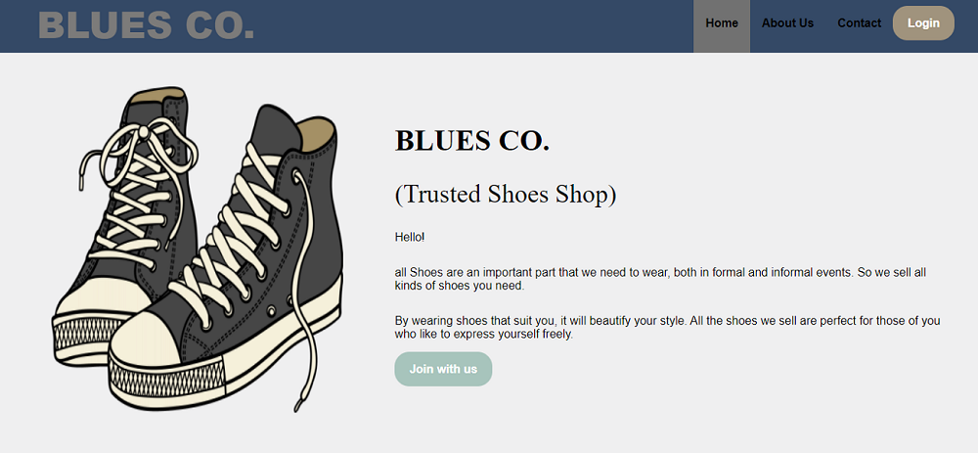

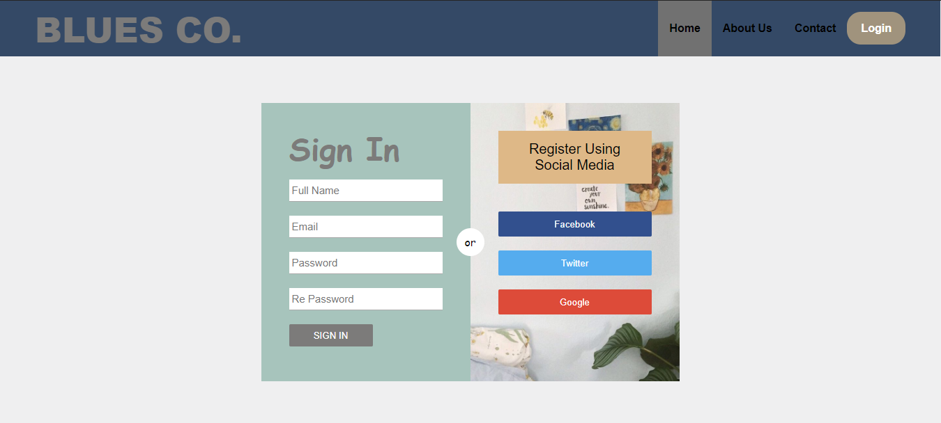

**HOME**

If you scroll through the home page, you will see examples of the shoes we sell and the partners who work with our company.

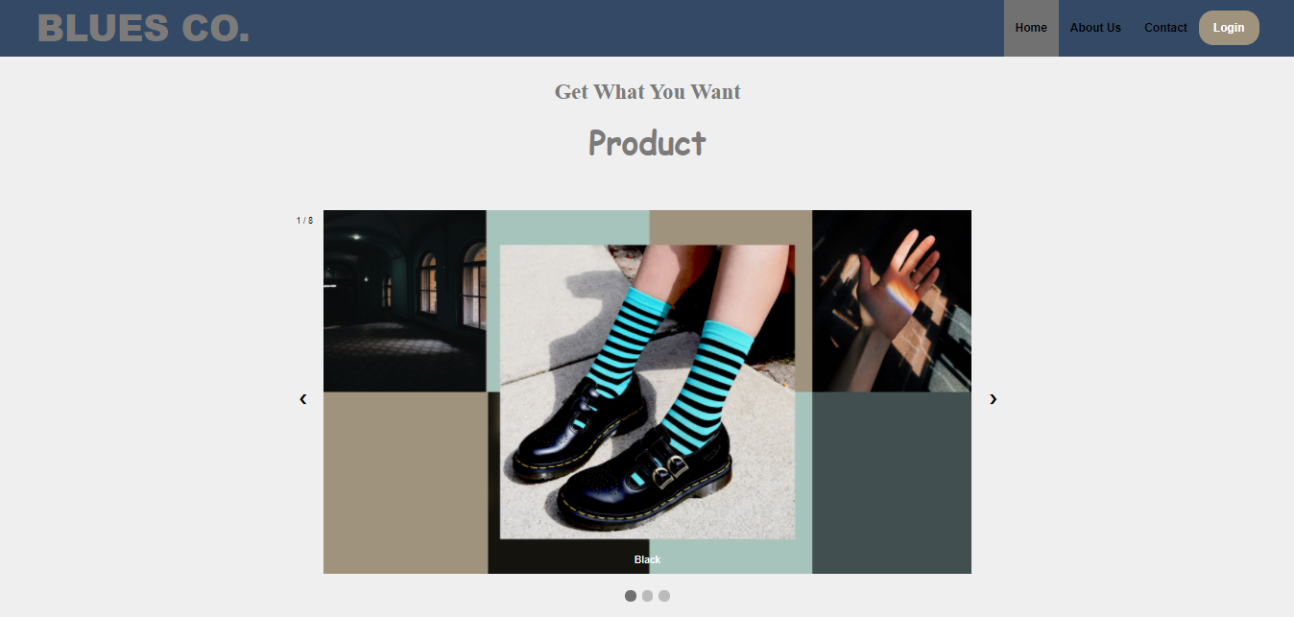

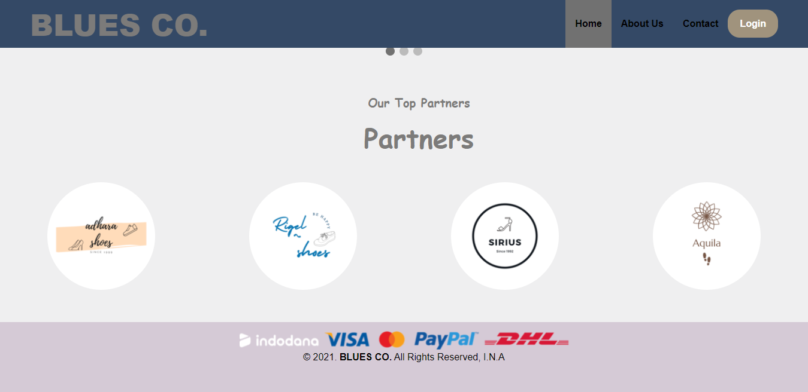

**About Us**

In About Us page, customers can read the purpose of us makes this website. If the customers clicks the "learn more" button it will display our company team.

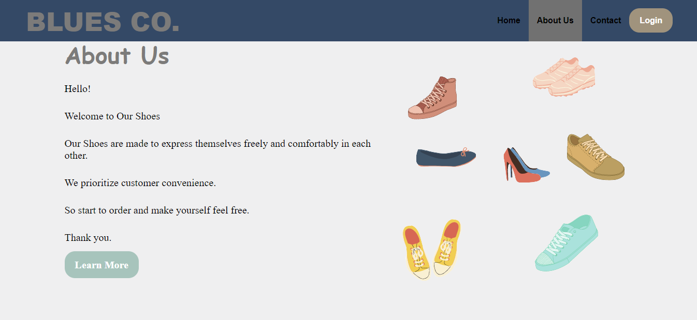

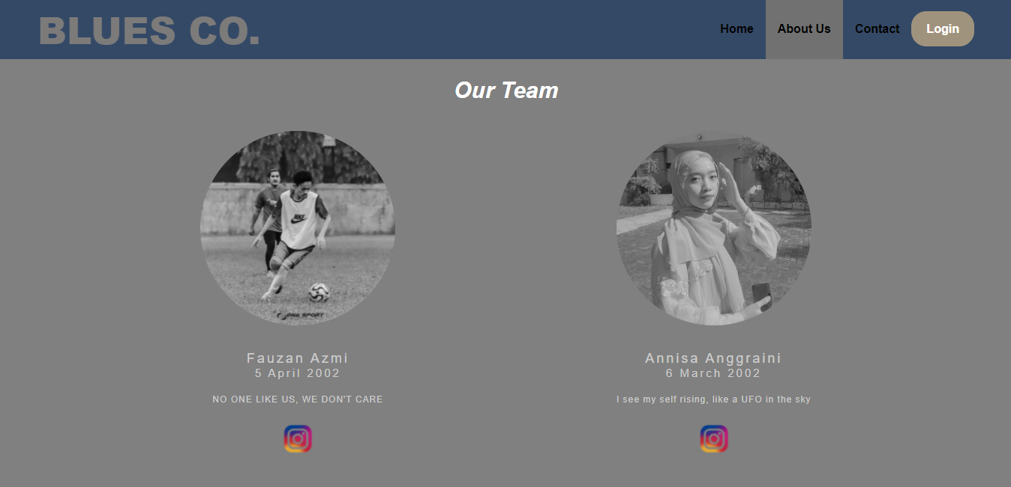

**Contact**

In Contact page, customers can contact us with the contact that has been attached.

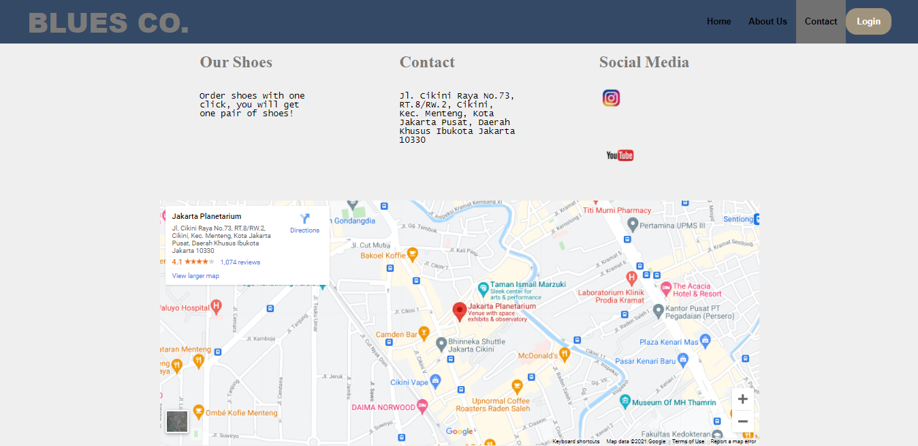

**Login**

In Login page, customers can log in using an existing account. If you click "create an account?" then you will arrive at the sign in page.

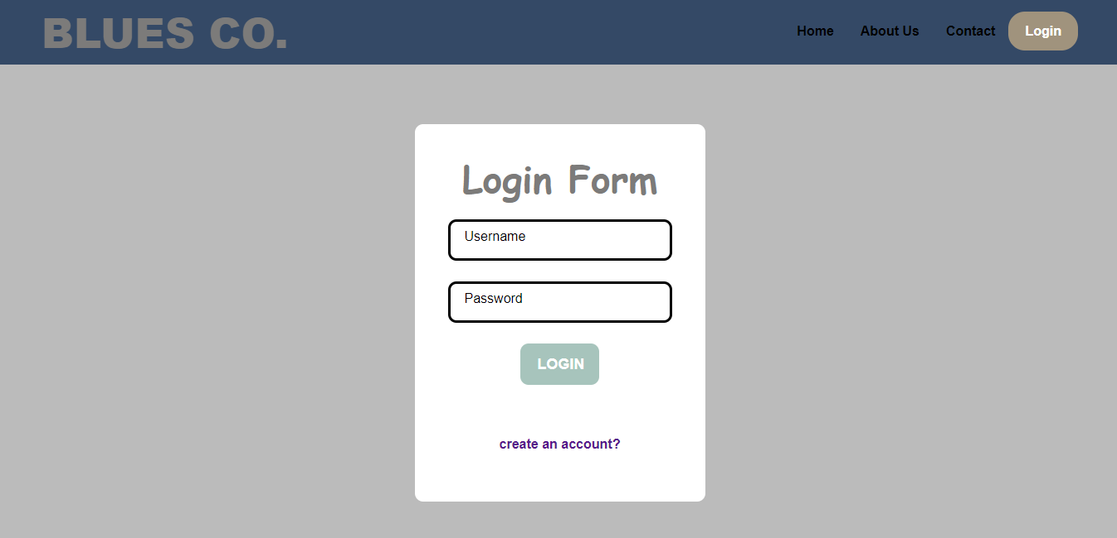

**CONFIGURATION**

**Hardware :** Ryzen 5 4600h + GTX 1650Ti

**Operating System :** Windows 10

**Software :** Visual Studio Code and Sublime Text

|  |  |  |
| --- | --- | --- |
| **PROJECT FILE DETAILS** | | |
| **S.No** | **File Name** | **Remarks** |
| 1. | index.html | HTML |
| 2. | signin.html | HTML |
| 3. | aboutus.html | HTML |
| 4. | bio.html | HTML |
| 5. | contact.html | HTML |
| 6. | login.html | HTML |
| 7. | style.css | CSS |
| 8. | Blues CO | Microsoft Word |
| 9. | Blues CO | Microsoft Power Point |

\

sssssssssss